**OUTPUT**

**Google Chrome browser:**

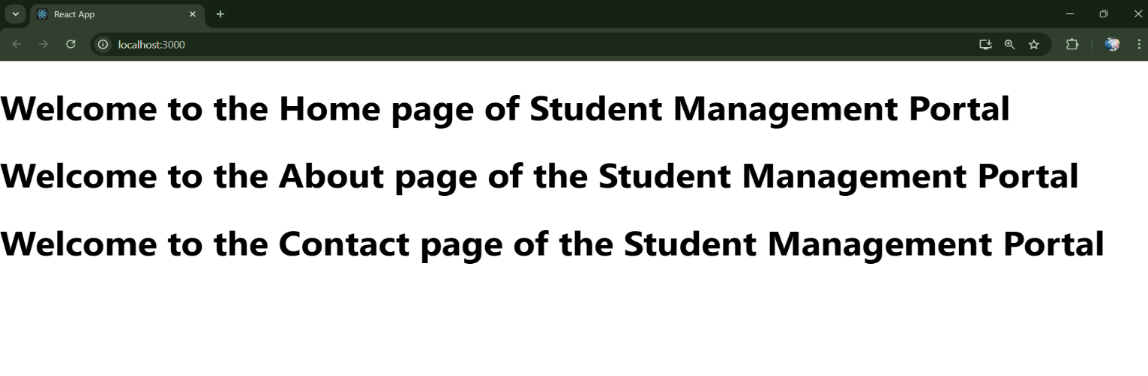

**Local :- http://localhost:3000**